Chapter 3
Name: Nicolás Rodríguez Camacho
Code: 20181165268
Load CSV files with the Python Standart Library

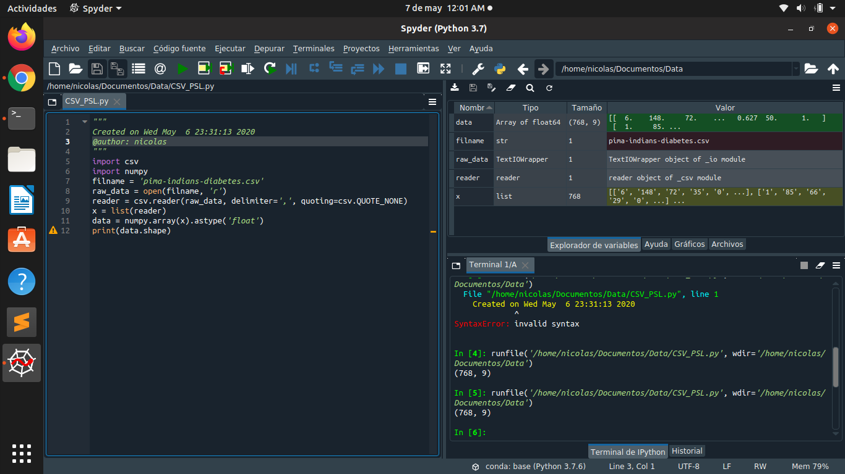
Load CSV files with NumPy
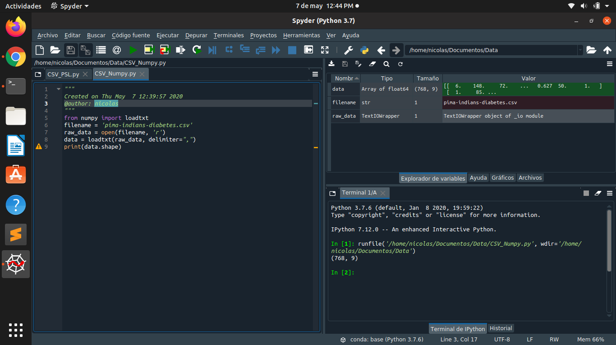
Load CSV file with NumPy directly from a URL
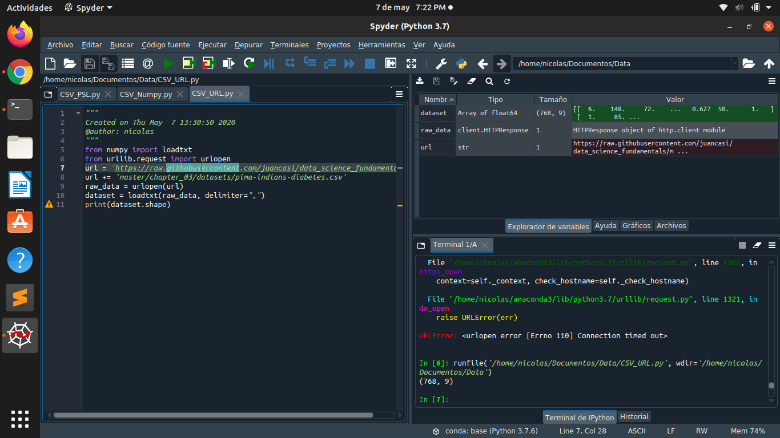
Load CSV files with Pandas
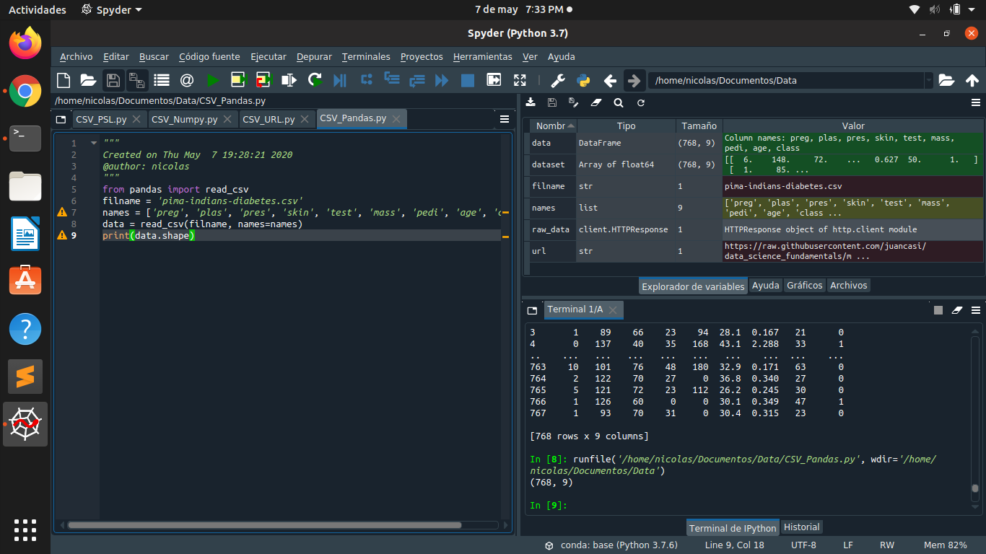

Load CSV data with Pandas directly from a URL
